PROMPTS WITH RESPECTIVE IMAGES

Generate images of protein powder, Creatine powder, and Whey powder boxes of 500 gm with a white background
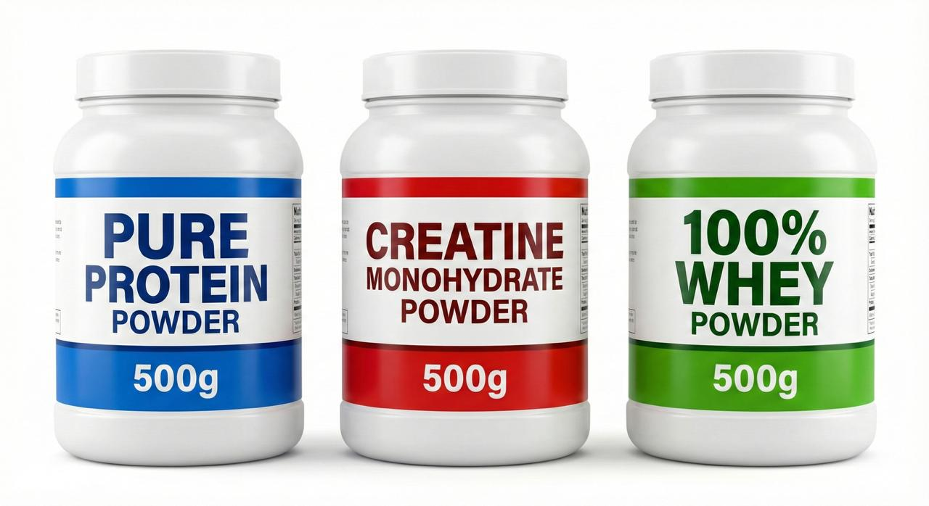
make a jar of blue color for the protein powder brand name "AXON."
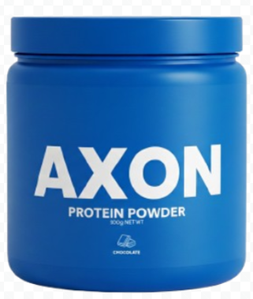
it should be written only protein powder

make a jar of red color for creatine powder brand name "AXON"
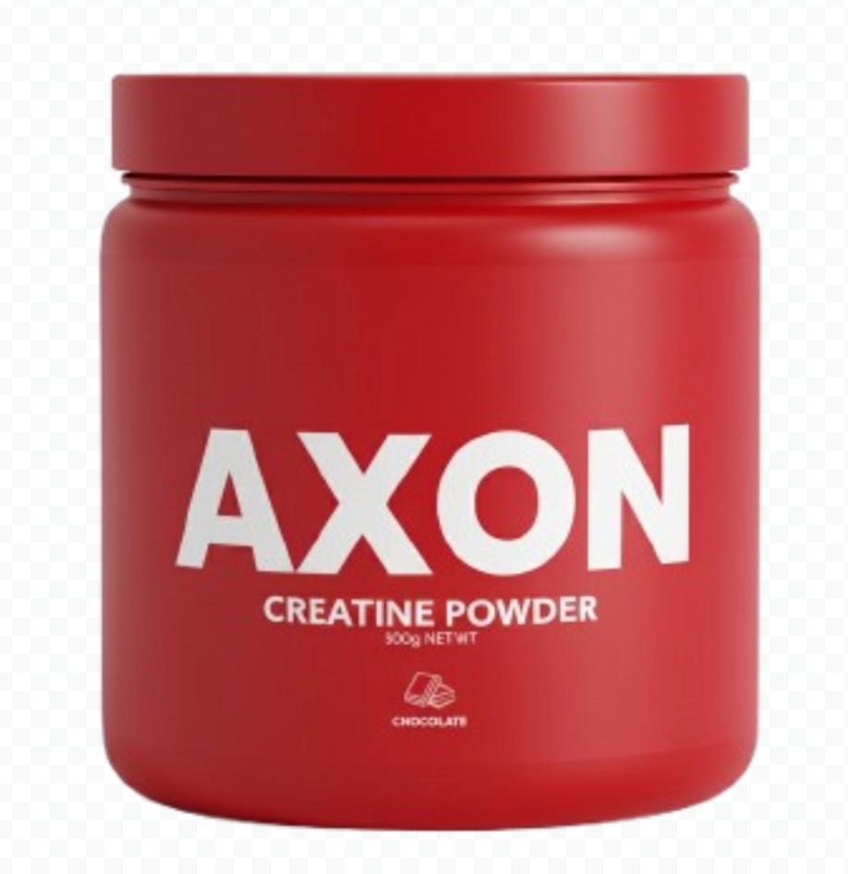
make two dumbells of name AXON
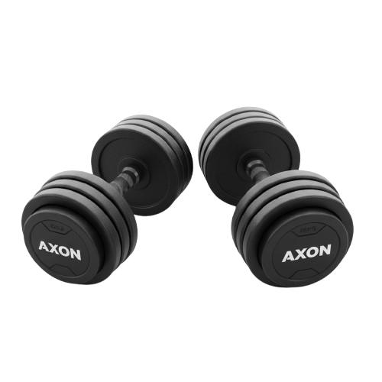
Make a muscle milk bottle with Axon Name brand and a transparent background
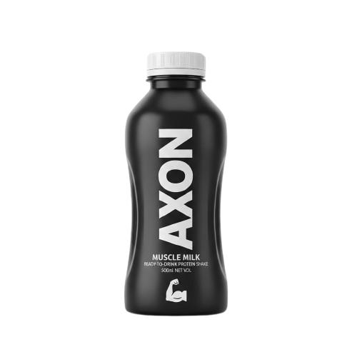
make a diet plan book brand name "AXON"
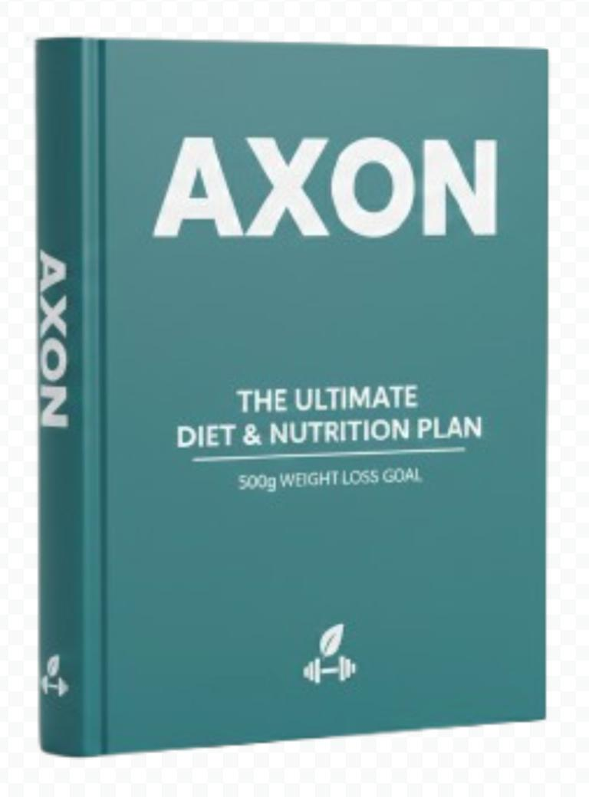
generate a jar of glutamine caps of the brand name Axon
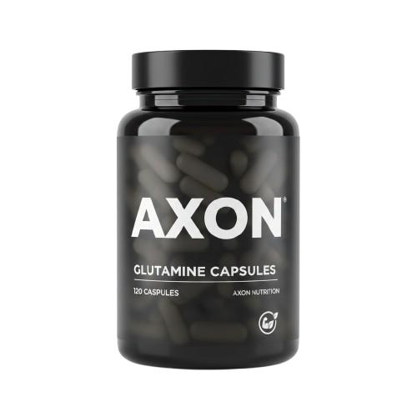

give me a graph of my health with a white background
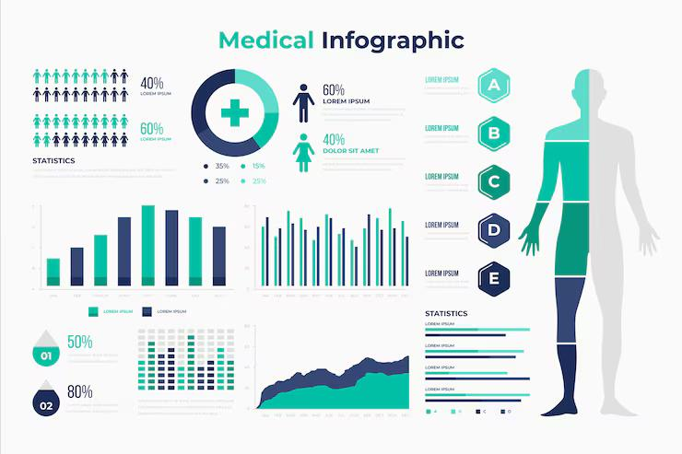

Generate a jar of Shilajit of the brand name Axon
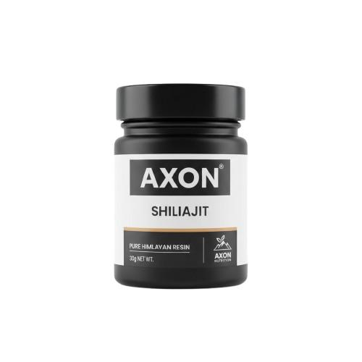
AI USAGE AND IMPLEMENTATION

Why AI was Suitable for the Theme
Generative AI was highly suitable because it allowed us to create a visually consistent and unique brand identity for AXON Nutrition. Creating a full line of professional-grade product photography—including protein powder, creatine, and glutamine—would have been expensive and time-consuming. AI allowed us to generate high-quality, perfectly lit, and uniform product mockups quickly and efficiently without the cost and logistics of a professional photoshoot.

Challenges in Prompt Engineering
The primary challenge in prompt engineering was achieving a perfectly consistent bottle and label design across all 10+ products (powders, capsules, liquids, and the book). Initial attempts resulted in variations in the AXON logo font, jar dimensions, and label placement. This was resolved by meticulously defining parameters such as "matte black or primary color container," "white label," and "product title in bold white sans-serif font" in every single prompt, which significantly increased the number of attempts needed before achieving the desired brand cohesion.

Ethical Considerations in Using AI Imagery
We prioritized ethical use by strictly adhering to the project's guidelines. We ensured that all AI-generated content is clearly disclosed and labeled on the website itself, as using AI for product imagery is considered a dishonest practice in real e-commerce. We provided proper attribution to the AI tool used and included a prominent disclaimer stating that all images are AI-generated, promoting transparency. We also focused on creating generic mockups to avoid copyright infringement from existing supplement brands.

